Cosmic Rays in MoNA

Eric Johnson
8/08/03

National Superconducting Cyclotron Laboratory

Department of Physics and Astronomy
Michigan State University
Advisors: Michael Thoennessen and Thomas Baumann

Abstract:
MoNA is a Modular Neutron Array made up of 144 bars of plastic scintillator. Each bar is 10 cm by 10 cm by 200 cm and has a photo multiplier tube on each end of the bar. MoNA is modular because the bars can be arranged in any configuration. The present experimental operation of MoNA one column (16 bars) was used to record events from cosmic rays. This data was used to calibrate the electronics, and also to test the data recording set up.

Introduction
MoNA is a large area, highly efficient neutron detector. The current set up of MoNA has nine columns of sixteen detector bars. Each bar is two meters long and has a photomultiplier tube on each end. Eventually MoNA will have passive iron converters placed in front of the last six columns to improve the efficiency of detecting high energy (100+ MeV) neutrons. This corresponds to the designed set up of MoNA, however the detector walls have the ability to be arranged in any way.

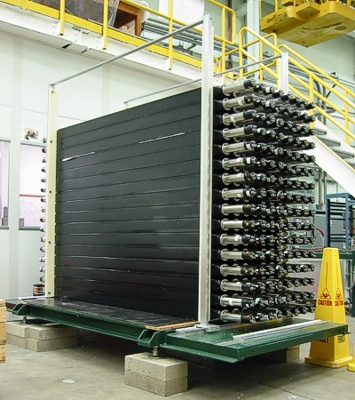

Figure 1: MoNA in 9x16 array

The basic detection method of MoNA is similar to other neutron detectors; the neutrons enter a scintillating material that transmits light to photomultiplier tubes through internal reflection. When complete, MoNA should have a neutron detection efficiency of around 70 % for single neutron events, and around 49 % for double neutron events. The single neutron efficiency is seven times better than the current neutrons walls at the NSCL, and almost fifty times better for double neutron hits.

Physical Set Up
MoNA will be used to study neutron rich nuclei. These nuclei are produced by the Coupled Cyclotron Facility, and bombard a target in front of a sweeper magnet. They will break up into a charged fragment and one or more neutrons. The magnet will pull aside the charged particles from the beam, allowing the neutrons to head toward MoNA at zero degrees. The setup of the sweeper magnet can be seen in Figure 2.
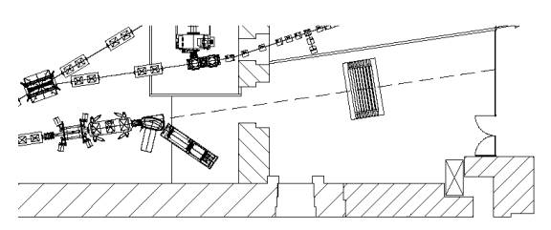
Figure 2: Top view of the end of the beam line, sweeper magnet, and
MoNA. The dashed line represents the center of the neutron beam.

After passing through the sweeper magnet the neutron beam travels freely through air for about ten meters. Detecting the charged fragments behind the magnet and the neutrons at MoNA will allow time of flight calculations to be made. Once the neutrons strikes the bars the PMTs detect the event and send an anode and a dynode signal. The anode signal goes to a constant fraction discriminator, and from there to a TDC and also an FPGA logic unit. The dynode signal is sent through an inverter box and then to a QDC.

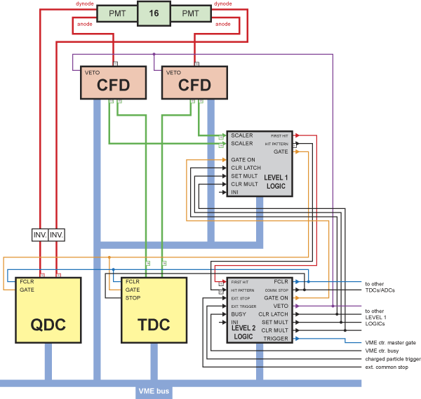
Figure 3: Schematic of MoNA electronics. During the present test the Level 2
Logic unit was not completed so a slightly different set up was used.
Experimentation and Analysis
The purpose of this setup was to test the electronics by looking at cosmic rays in MoNA. The experiments discussed in this paper were all run with the electronics set up as shown in the Figure 4. The FPGA logic unit was set to send a signal only if there was a coincidence from both sides of the bars. The QDCs began integration of the charge from the dynodes once it received a gate from the FPGA. The TDCs were set to start when they received a signal from the CFDs and to stop when they received the gate from the FPGA.
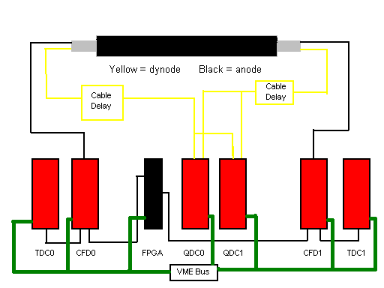
Figure 4: Experimental electronics schematic

As the first step the energy signals for every bar needed to be gain matched. To do this the high voltages were adjusted to move the cosmic ray peaks to approximately the same channel for every bar. The difference between spectra that has not been gain matched and spectra that has is easily distinguishable as seen in Figure 5.
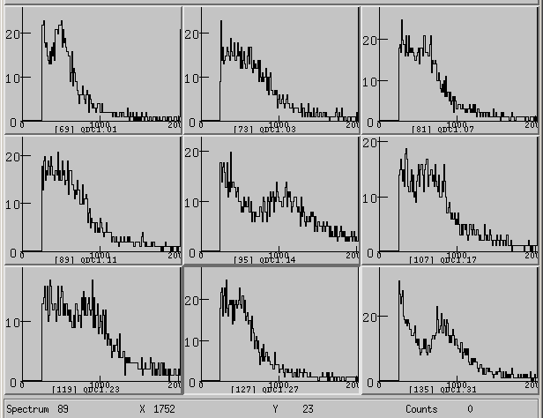
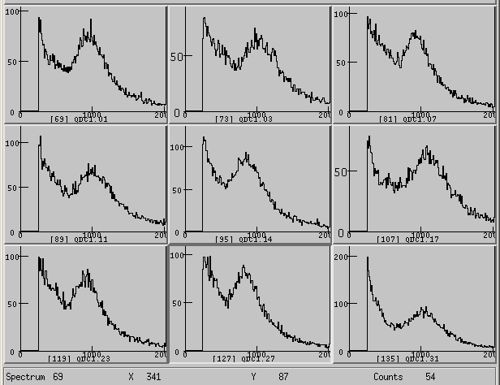

Figure 5: Raw QDC1 spectra before and after rough gain matching.
Once the electronics were in working order the original plan for this test was to investigate the significance of reflections inside the bar. The plan was to give the same dynode signal to two different QDCs. By delaying the gate to one of them we would be able to get data from just the tail of the signal. An example of the dynode signal is shown in Figure 6.

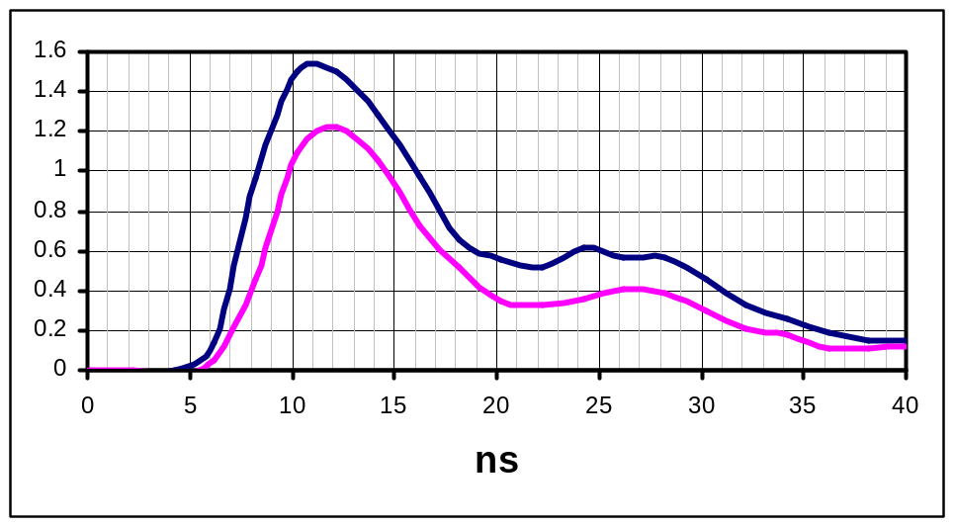

Figure 6: Dynode signal with possible reflection in tail [Komarov, private comm.].

A test was run with a 23 ns delay added to the gate for QDC1. This caused QDC1 to integrate over a smaller portion of the dynode signal, which caused the QDC1 data to be smaller than QDC0. This can be seen in the two-dimensional plots in Figure 7. When the QDCs get the same gate the plot looks like y equals x, but when the delayed gate is added the size of QDC1 is decreased, and along with it the slope of the line, as seen in the 2-D plots in Figure 7. The next thing that was looked at was the reason for the double lines in both the normal and delayed 2-D plots.
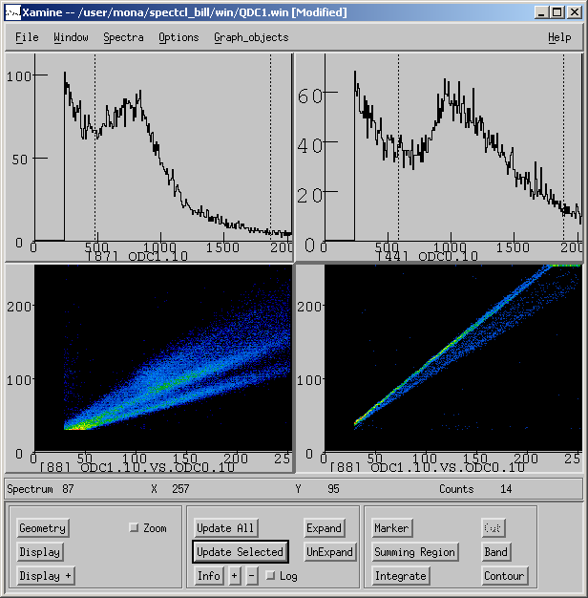

Figure 7: Spectra with delayed gate (left) and spectra with normal gate (right).

This was puzzling because if the QDCs were getting the exact same signal and gate there should be a one to one correlation for all events; which would give one single band of counts. The problem causing the dual bands was found in the gate created by the FPGA. The gate had a jitter on the backside; this jitter caused the QDCs to integrate over two different areas, which gave two separate maximums in the spectra, as seen in the left spectrum of Figure 8. To be sure that the jittering gate was the problem, another run was taken with the FPGA gate put through a discriminator. After this was done the spectra had only peak as seen in the right spectrum of Figure 8. The reason the Level 1 FPGA had a jitter was because the gate gets a stop from the Level 2 FPGA, since the Level 2 FPGA was not being used the Level 1 gate stopped at different times. The FPGAs were designed like this so that both fast and slow neutrons could be caught with one varying gate. After seeing what varying gate size does to the data, it was realized that the Level 1 FPGA must be reprogrammed to give a gate of constant width.

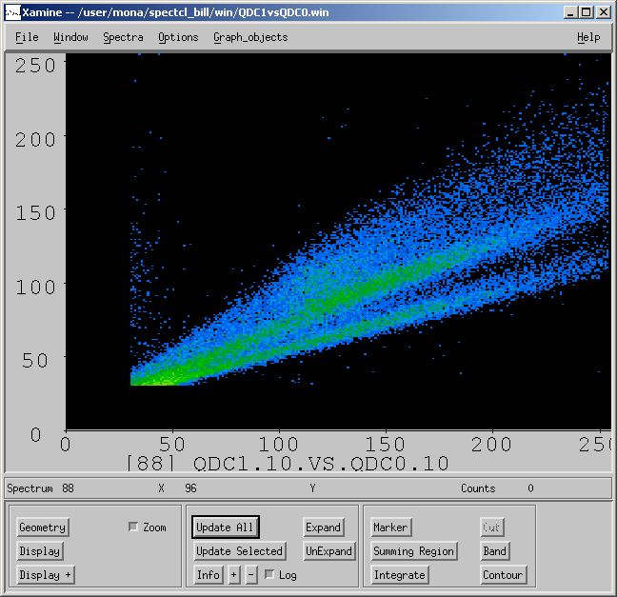
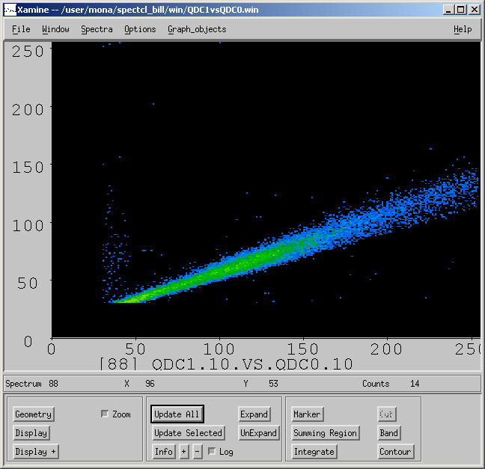

Figure 8: Spectra with and without a varying gate.

Another problem that was showing up in the spectra was the occurrence of double parallel lines in some channels of the QDC1 vs. QDC0 plots, this can be seen in the lower right spectra of Figure 9. The intensity of the second band was insignificant compared to the main band, but it was puzzling what was causing it to show up at all. A correlation was found between the 2-D plots with double lines, and the 1-D plots of the same channels of QDC0. For the corresponding 1-D plots the left side of the spectra is mostly flat, which is different from the rest of the spectra, which have a secondary peak and a spike. The two different spectra can be seen in the left side of Figure 9.

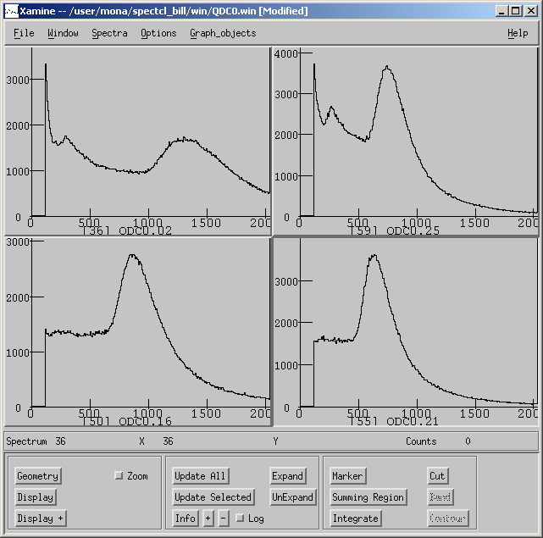
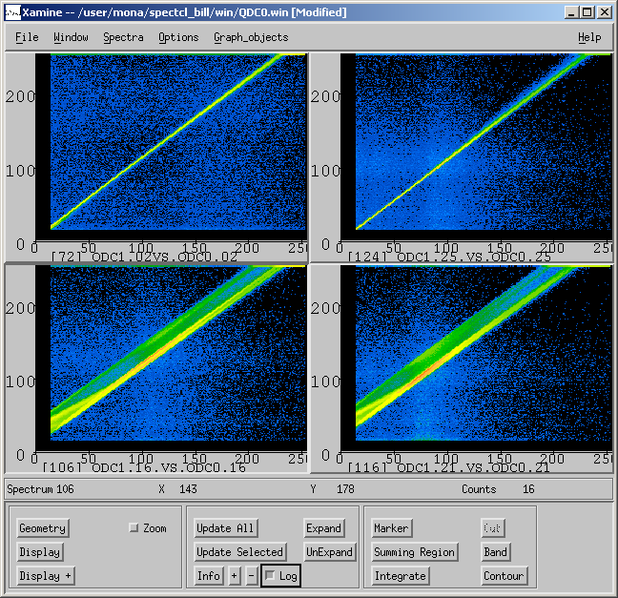

Figure 9: Double band and single band spectra with corresponding 1-D spectra

The time data can be used to find the position of each event. The position is found by subtracting the one of the TDCs from the other. This time difference spectra will represent the length of the bar, see Figure 12. Before this can be done the TDCs have to be calibrated; this was done by gating the TDCs with no delay, a 10ns delay, and a 20 ns delay. Data from each gate was taken for 20 minutes, all in one run. Using the spectra from this run and some simple calculations, the gain (ns/ch) was determined for each individual TDC channel. The next step in calibration was to determine the offset; this was done using the formula:

cal.TDC = gain*ch.x + offset.ch

It was decided to center the non-delayed peak of every channel at 1000. So by setting cal.TDC equal to 1000 the offset was the only variable left, and the TDCs were calibrated with both gain and offset. For the calibrated TDC spectra one channel equals 100 ps.
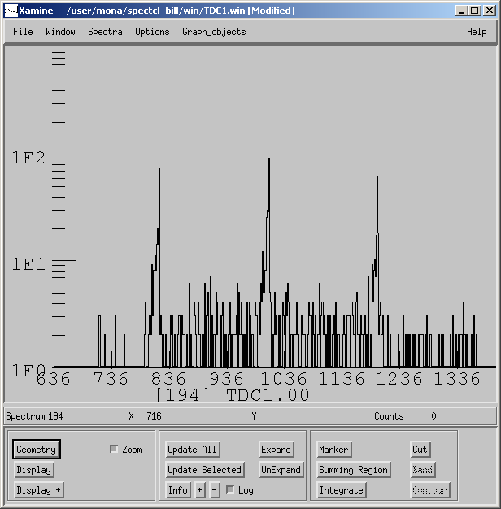

Figure 10: Spectra used to calibrate TDC1 channel 00
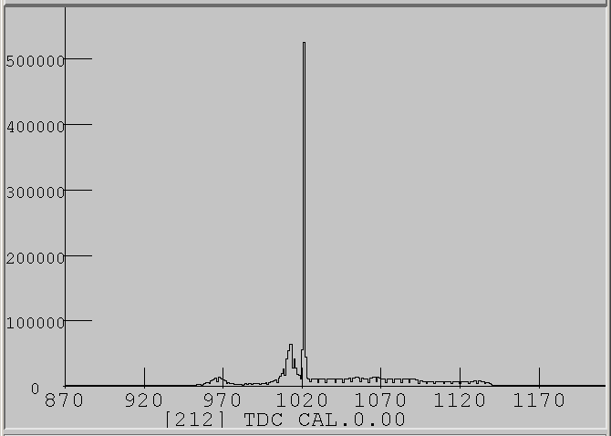
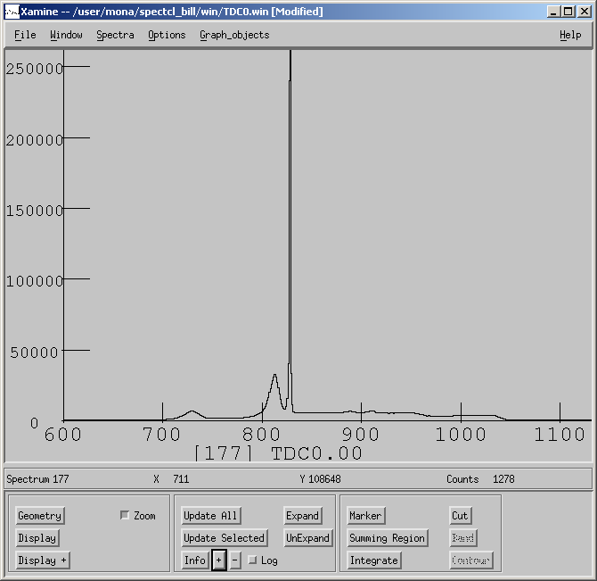

Figure 11: Raw and Calibrated TDC spectra.

Up to this point the I/O Register had received a start gate directly from the FPGA. Even though it allowed the electronics to run properly, this was not the correct way for the Register to be gated. The correct setup had the Register input receiving a latch that was started by the FPGA, and stopped by it’s own “acknowledgment of event” output. The other change was to create a veto signal for the QDCs while the computer was busy. This was done with a latch that was started by the output from previous latch, and stopped by the “end of event” output from the Register. This allowed almost ten times more data to be taken than with the previous setup.
Once data is taken it can be filtered and looked at many different ways. By using the time difference spectra (Figure 11) to simulate the bars it is possible to get the number of events that occur in certain positions of the bars.
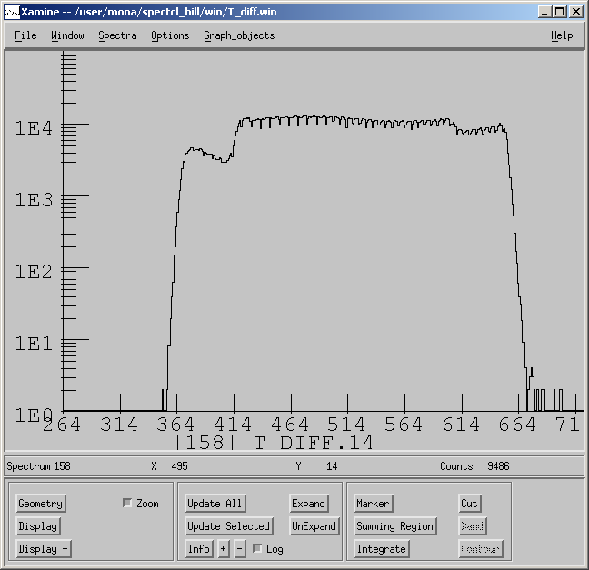

Figure 12: Time difference spectrum representing bar 14.

By making gates on the left side of bar 0, and the right side of bar 15, then creating an “AND” gate from them it is possible to see only the events that occur in both of these two small regions, shown in Figure 13. What this represents is the cosmic rays that enter MoNA at the top bar on the right and leave bottom bar on the left. By gating the middle bars on the “AND” gate it is possible to see where the cosmic rays passed through each bar.
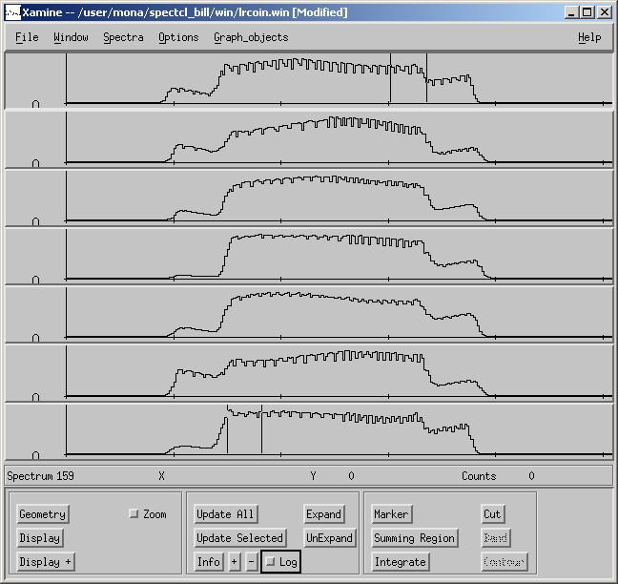

Figure 13: Spectra of the time difference representing the detector bars.

The path of the cosmics should be seen in Figure 14, but the data did not line up very well, and there were double peaks. Both of these things are still being looked into.

Conclusion:
What was found through this project is that new electronics need to be thoroughly tested before they are considered working. For the most part the components tested were in working order, but there were small inconsistencies in much of the data that could cause problems if a project involved looking for rare events. More details of the MoNA project can be found at: http://groups.nscl.msu.edu/mona/home.html.

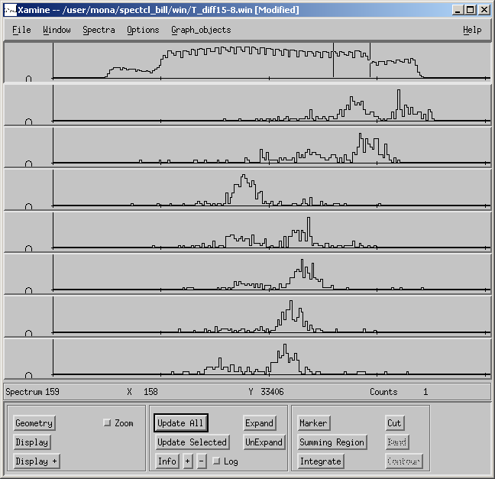

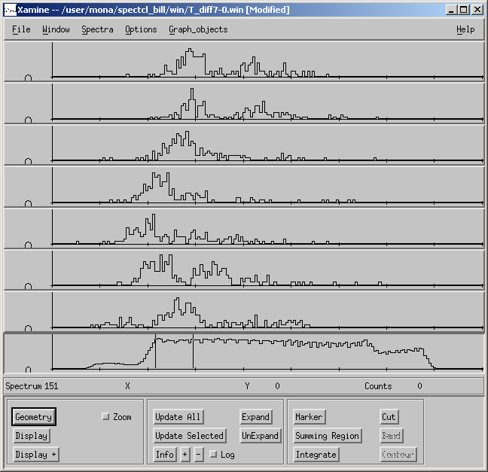

Figure 14: Shows the gated area of the top and bottom bars, and the paths the cosmic rays take through the detector.

References

http://groups.nscl.msu.edu/mona/home.html

Komarov, Sergey private communications

